ABSTRACT

The Services Hub initiative seeks to fill the gap in today's vast digital ecosystem between regional providers and users. The idea for the project began as a result of realizing how difficult it is for regional providers to connect with potential clients.

Services Hub is a user-friendly online application that prioritizes accessibility and user-friendly layout in order to address these issues head-on. Facilitating home services through internet channels is highly demanded in our fast-paced, technologically-driven era. With our platform, clients can easily order services from the convenience of their fingertips, including installations, haircuts, cleaning,installation,repair and many more.

To address these issues, Services Hub introduces a user-friendly web application focusing on intuitive design and accessibility. Additionally, this program gives residents employment possibilities in their areas by attending to their job requirements. Our ultimate objective is to provide excellent services while promoting local economic development and empowerment. Our aim is to provide best services.

सार

सर्विसेजहबपहलक्षेत्रीयप्रदाताओंऔरउपयोगकर्ताओंकेबीचआजकेविशालडिजिटलपारिस्थितिकीतंत्रमेंअंतरकोभरनेकाप्रयासकरतीहै।परियोजनाकाविचारयहमहसूसकरनेकेपरिणामस्वरूपशुरूहुआकिक्षेत्रीयप्रदाताओंकेलिएसंभावितग्राहकोंसेजुड़नाकितनामुश्किलहै।

सर्विसेजहबएकउपयोगकर्ता-अनुकूलऑनलाइनएप्लिकेशनहैजोइनमुद्दोंकोसीधेसंबोधितकरनेकेलिएपहुंचऔरउपयोगकर्ता-अनुकूललेआउटकोप्राथमिकतादेताहै।हमारेतेज़गतिवाले, तकनीकीरूपसेसंचालितयुगमेंइंटरनेटचैनलोंकेमाध्यमसेघरेलूसेवाओंकीसुविधाकीअत्यधिकमांगहै।हमारेप्लेटफ़ॉर्मकेसाथ, ग्राहकआसानीसेअपनीउंगलियोंकीसुविधासेसेवाओंकाऑर्डरकरसकतेहैं, जिसमेंइंस्टॉलेशन, हेयरकट्स, सफाई, इंस्टॉलेशन, मरम्मतऔरकईअन्यशामिलहैं।

इनमुद्दोंकोसंबोधितकरनेकेलिए, सर्विसेजहबनेसहजडिजाइनऔरपहुंचपरध्यानकेंद्रितकरतेहुएएकउपयोगकर्ता-अनुकूलवेबएप्लिकेशनपेशकियाहै।इसकेअतिरिक्त, यहकार्यक्रमनिवासियोंकोउनकीनौकरीकीआवश्यकताओंकोपूराकरकेउनकेक्षेत्रोंमेंरोजगारकीसंभावनाएंप्रदानकरताहै।हमाराअंतिमउद्देश्यस्थानीयआर्थिकविकासऔरसशक्तिकरणकोबढ़ावादेतेहुएउत्कृष्टसेवाएंप्रदानकरनाहै।हमाराउद्देश्यसर्वोत्तमसेवाएँप्रदानकरनाहै।

TABLEOFCONTENTS
Title PageNo.
Abstract ....iv
सार v
- Introduction 1
  - Recognitionofneed 1
  - ProblemIdentificationand Requirement 1
  - InformationGatheringTools& Strategies 2
  - AdvantagesofServices Hub 3
- SystemAnalysis 4
  - FeasibilityStudy 4
  - DataFlow Diagram 7
    - Level-0DFD 7
    - Level-1DFDforAdmin 8
    - Level-1DFDforProvider 9
    - Level-1DFDforUser 10
- SystemDesign 11
  - Table Structure 11
  - ER Diagram 14
- Testing 15
  - Unit Testing 15
  - Integration Testing 16
  - Validation Testing 18
- Implementation 19
- SampleForms&Reports 20
- Conclusion and Future Scope 26
Bibliography 27
PlagiarismReport 28

INTRODUCTION

Recognitionof need:
- Increasing Demand for Convenience: Due to their busy lifestyles, users are looking for useful solutions that can save their time and effort. By sending experts to their door, home services provide a direct solution to this requirement.
- Unreliable Platforms: A lot of clients have trouble locating reliable local providers for a variety of services. This need is filled by a single platform that brings together certified service providers, giving clients confidence and peace of mind.
- Need for Streamlined Processes:Using traditional techniques to look for service providers, weigh choices, and make reservations can be time-consuming for customers. By providing a one-stop shop for all of their service needs, a unified platform streamlines the entire process and makes it easier to understand.
- Desire for Quality and Reliability:When it comes to residential services, customers place a high value on quality and dependability. The platform fulfills the demand for reliable and trustworthy service providers by employing strict quality control procedures and curating a network of recognized specialists.

Problemidentificationandrequirements:
ThisProjectaimsataddressingthefollowingproblemsfacedbylocalbusinesses:
- Authentication:Both custom and service providers can give their details to register our Platform and after registration they can simply log in with the use of user id and their password
- Customer and Provider Dashboard:Both customers and provider have their own panels in customer panel a customer can only see their service details like date time slots provided details and many more and in provider panel a provider have access to process service requests customer details manage view and update service listing and many more.
- Search Services :The search services enables customer too efficiently find specific service offered on platform with a wide array of services like AC maintenance, bathroom cleaning, utensils washing and many more. A user can easily choose and book their desirable surveys they want.
- Feedback :The Feedback system facilitate communication between customer and service provider allowing for the exchange of reviews and ratings based on the quality of service provided.
- Appointment Scheduling:Our platform's user-friendly appointment scheduling feature makes it simple for clients to reserve services for the time and day of their choice. This feature guarantees that clients enjoy convenient and timely service while also assisting businesses in effectively managing their calendars.

1.3 Information Gathering tools and strategies:
- Physical Survey:we went to the Residential society and interact with Sanskar Jain [202,Agarwal Complex, Patankar Bazaar ,Gwalior . Phone No- 7089603630] living there and find what type of services they need in day to day life.
- Interview:Weconducted interview from those persons who use similar types of websites like Urban Company, Zimmber. We interact with Khushi Gupta, Nupur Srivas and Sanskar Jain, they told us what type of challenges they faced while using these websites.
- Online Research :We go through the online research to find what type of service provider platform are already exist.we visited Urban Company, Zimmber and Vijay home services
- Feedback:We go through the similar websites like Urban Company, and list out the problems through feedback and tried to overcome these.

1.4 Advantages of Services Hub:

- Convenient-Customers can book a wide range of services from the comfort of their own home, eliminating the need to travel to multiple locations for different services.
- Time Sharing-By offering services at home, customers save time that would otherwise be spent commuting to and waiting at services provider’s location.
- Flexibility:Customers can scheduled services at their preferred time slot, allowing them to manage their appointments according to their busy schedules.
- User Friendly :Our Platform is designed keeping in mind, making it easy to book the services you need. With a simple interface and navigation.

- Dependable Service Providers:Based on their credentials, track record, and client testimonials, our platform carefully screens and chooses dependable service providers. This increases consumer pleasure and peace of mind by guaranteeing that they obtain top-notch services from reliable professionals.

SYSTEMANALYSIS
2.1. Feasibility Study:
2.1.1. Economic Feasibility-

Personal :-
S.NO | Title | Amount
1 | Database Specialist 20 Days in (3 Months) | 2,500
2 | Back-end Developer 60 Days in (3 Months) | 2,500
3 | Front-end Developer 45 Days in (3 Months) | 2,000
4 | Hardware Cost | 1,300
5 | Software Cost | 1,500

- Other Expenses :-

S.NO | Title | Amount
1 | Workspace Facilities | 1,200
2 | Electricity Cost 60 unit (9rs/unit) | 540
3 | Stationary (for documentation) | 180

Total Cost : 11,720

Total | 11,720/-

2.1.2Technical Feasibility-

- Programming Languages:-
S. No. | Specification | Details
1. | Front-end | CSS3,MaterialUI,Bootstrap5,HTML5
2. | Back-end | Node.JS,Express.JS
3. | Database | MySQL

- Hardware requirement:-

S. No. | Specification | Description
1 | CPU | i3-8thgenandabove
2 | RAM | 4GBand above
3 | Storage | 256GBSSDandabove
4 | NIC Card | For internetconnection

iii.Software requirement:-

S. No. | Specification | Details
1 | OS | Windows7 Professional andaboveorMAC
2 | Browser | Chrome,Edge,Mozillae.t.c
3 | SQLServer | MySQLWorkbench8.0CE
4 | IDE | VisualStudio 2022

2.1.3.Behavioral Feasibility-
a. We will offer free training courses for three months in order to make the services hubadaptation easier.
b.We are giving warranty for 1 year and if any big and error will come during this period oftime , we will ensure to resolve this.
c.By establishing a 24/7 customer support support center over company which ensures thatusers receive timely get assistance. This initiative not only resolve user issues promptly but also empowers them with the knowledge and skills to maximize their experience on theplatform.

2.2 DataFlowDiagram

Level–0 DFD:-
SERVICES
HUB
Admin
Guest
User
Provider
info
Book
Services
User
info
Provider
List
Services
Booking
info
Feedback
info
View
Services

Level–1 :- DFD For Admin
Admin
User
2.3
Feedback
2.4
View
Services
2.6
Provider
2.1
Update 2.2.2
Add
2.2.1

Book
Service
2.7
Provider
Provider
info
Delete
2.2.3

Service
Booking
2.5
Login
List
services
User
info

Login
Home
Feedback
Feedback
info
Done
2.5.1

Cancel
2.5.2

Booking
Book
Service
User
Cancel
2.7.2

Booking
Services
Booking
info
status

contactNo

timeslot
timeslot

status

B_date

U_city

U_name

OK

B_date
timeslot
Create2.7.1

B_date

price
category

price

title

title

B_date

rating

comment

category

description

title

P_city

B_ID

S_ID

B_ID

F_ID

U_ID

S_ID

P_ID

Service
2.2
View
Service

Level–1 :- DFD For Provider
New
Registration
1
Provider
info
Booking
2.2
Update
2.1.2
Add
2.1.1
Delete
2.1.3
Done
2.2.1
Cancel
2.2.2
List
services
Feedback
info
Home
2
Login
1.1
Registration
1.2
Services
2.1
Provider
Feedback
2.3
Booking info
For Registered

For New

B-Data
OK

P_Name

provider provider
P_ID

OK OK

F_ID

S_ID

B_ID

comment
rating
category
timeslot
Tittle

Description

feedback Feedback

Description

Category

timeslot
titre
B-Data
OK

services booking

Level–1 :- DFD For User
User

New
Registration
1

For New

For Registered

U_Name

Registration
1.2
Login
1.1

User User
U_ID

Home
2
OK OK

User info
B_ID

S_ID
F_ID

Services2.1
Book
2.3
Book
Services
Feedback2.2
category
B_date
title

timeslot
Rating

Cancel
2.3.2
Services
Add
2.2.1
Create
2.3.1

View
services
timeslot
B_date
Comment
Rating

Feedback
Info
Feedback Booking

3. SYSTEMDESIGN

TableStructure

i. USER:-
S.NO | Field | DataType | Null | Key
1 | u_id | varchar(25) | no | primary
2 | u_Name | varchar(50) | no | -
3 | u_city | varchar(40) | no | -
4 | phone | Bignit(10) | no | -
5 | u_password | varchar(40) | no | -
6 | u_emailId | varchar(100) | no | -
7 | u_Address | varchar(250) | no | -

ii. PROVIDER:-

S.NO | Field | DataType | Null | Key
1 | p_id | varchar(25) | no | primary
2 | p_Name | varchar(50) | no | -
3 | p_City | varchar(40) | no | -
4 | p_Address | varchar(250) | no | -
5 | Contact_no | Bigint(10) | no | -
6 | p_password | varchar(40) | no | -
7 | p_email | Varchar(100) | no | -

S.NO | Field | DataType | Null | Key
1 | s_id | varchar(45) | no | primary
2 | Tittle | varchar(80) | no | -
3 | Price | int | no | -
4 | Description | varchar(500) | no | -
5 | Category | varchar(45) | no | -
6 | p_id | varchar(25) | no | foreign
7 | ImageLink | varchar(255) | no
8 | s_status | Varchar(20) | no
iii. SERVICES:-

iv. BOOKING:-

S.NO | Field | DataType | Null | Key
1 | B_id | varchar(45) | no | primary
2 | B_date | date | no | -
3 | Timeslot | Varchar(50) | no | -
4 | U_id | varchar(25) | no | foregin
5 | S_id | varchar(25) | no | foreign
6 | status | varchar(20) | no

v.FEEDBACK:-

S.NO | Field | Data Type | Null | Key
1 | F_id | Varchar(10) | no | primary
2 | Comment | Varchar(200) | yes | -
3 | Rating | int | no | -
4 | B_id | Varchar(10) | no | foregin

3.2 ERDiagram

User
Create
Booking
Feedback
U_password
Phonehone
U_addressss
U_City
EEmail_idEmEMail
U_id
-id
F_id
Commentment
Rating
B_id
Timeslot
Contain
Services
Description
Price
S_id
Category
Tittle
Provide by
Provider
P_password
P_id
Contact_no
P_city
P_address
P_name

B_date

4.TESTING:-

4.1.Unit Testing:- Weperform unit testing on each website component using various test data to ensure functionality we validate input types against corresponding outputs for admin , login,provider login/sign up, user login/sign up ,listing addition and feedback forms additionally we separately test users , admin and provider modules.
Test  Caseid | Section | Elementname | Testdata | Expected  result | Actual  Result
TC-001 | Admin  login | Username,  Password | NoData | Pleasefilloutthisfield. | Testcase  passed.
TC-001 | Admin  login | Username,  Password | Username/  ************ | Invalid details | Testcase passed.
TC-001 | Admin  login | Username,  Password | Admin/  ******** | Successfully  Logged in. | Testcase passed.
TC-002 | Provider  Registration | Username, Password , city, Address, EmailID, PhoneNo , Name | NoData | Pleasefilloutthisfield. | Testcase  passed.
TC-002 | Provider  Registration | Username, Password , city, Address, EmailID, PhoneNo , Name | Shiv123,**** , Gwalior , Danaoli,abc,7223018695, Shivam Rathi | Invalid Details | Testcase passed.
TC-002 | Provider  Registration | Username, Password , city, Address, EmailID, PhoneNo , Name | Shiv@123 , ****, Gwalior  Danaoli ,Shivam123@gmail.com , 7223018695, Shivam Rathi | Successfully  Registered  Loggedin. | Testcase passed.

TC-003 | Provider  Login | Username ,  Password | NoData | Pleasefillout  thisfield. | Test case  passed.
TC-003 | Provider  Login | Username ,  Password | Username/  ******* | Invalid  Details | Testcase passed.
TC-003 | Provider  Login | Username ,  Password | Raj@gamil.com,  ******** | Successfully  Logged in. | Testcase  passed.
TC-004 | User  Login | Username,  Password | NoData | Pleasefillout  thisfield. | Testcase  passed.
TC-004 | User  Login | Username,  Password | Username/  ******** | Invalid  Details | Testcase passed.
TC-004 | User  Login | Username,  Password | Om@gmail.com,  ***** | Successfully Loggedin. | Testcase passed.
TC-005 | User  Registration | Name , EmailID ,  PhoneNo, City,  Address,Password, Username | NoData | Pleasefillout  thisfield. | Testcase  passed.
TC-005 | User  Registration | Name , EmailID ,  PhoneNo, City,  Address,Password, Username | Shivam , abc, 7223018695, Gwalior,  Chetakpuri,****** ,Shiv12 | Invalid  Details. | Testcase passed.
TC-005 | User  Registration | Name , EmailID ,  PhoneNo, City,  Address,Password, Username | Shivam, Shivam@gmail.com, 7223018695, Gwalior,  Chetakpuri, ****** ,  Shiv12 | Successfully Loggedin. | Testcase passed.

4.2. Integration Testing:It was conducted to ensure seamless interaction between various modules of the website. Each individual unit, including the admin module, user module, service provider module, and homepage functionalities, was integrated to assess the overall functionality of the web application.

During integration testing, we verified the communication and data flow between different modules, ensuring that they work harmoniously together to achieve the desired functionalities. By integrating the admin, customer, and service provider modules into a unified web application, we evaluated the overall performance and usability of the platform.

4.3. Validation Testing:These tests are performed on the final design to validate the system's ability to operate as specified.We perform these tests to check various functionalities:

- Admin Login - Admins can log in and perform privileged operations on the website, such as managing user accounts, viewing analytic, and updating site content .

- Provider Registration - Providers can register themselves by providing necessary information such as contact details, services offered, and pricing.

- Provider Login - Only already registered providers can log in to the website, but only with correct login credentials. Upon login, providers gain access to their dashboard, where they can manage their services and bookings.

- Add Service - Providers can add services only after logging into the website. They can specify service details, upload images, and set pricing information.

- Manage Service - Providers can edit and delete service listings as per their needs. They can easily edit the data without any requests if they wish to.

- User Registration- User can register themselves.

- User Login- Only already registered User can login to the website that too only with correct login credentials.

- Book Services - To book services, users need to first log in or register. Once logged in, users can browse through available services and book appointments based on their preferences and availability

5.IMPLEMENTATION
Firstly,weneedtoinstallsomeIDEsoftware'sforimplementingourprojectwhichareasfollows:-

5.1.VisualStudioCode:-
- GototheofficialVisualStudiowebsite:https://visualstudio.microsoft.com/downloads/
- Select the Visual Studio version that you wish to install by clicking the "Download" button.
- Choosethecomponentsyouwanttoinstall,suchaslanguages,frameworks,and tools.
- To start the installation procedure, click the "Install" button.
- Followtheinstallationwizardandselecttheoptionsthatsuityour needs.

5.2.MySQLWorkbench:-
- Go to the official Go to the official MySQL Workbench website: https://dev.mysql.com/downloads/workbench/
- SelecttheappropriateversionofMySQLWorkbenchforyouroperatingsystem.
- Clickonthe"Download"buttontostartthe download.
- Oncethedownloadiscomplete,runtheinstaller.Followtheinstallationwizardandselect the options that suit your needs.
5.3.NodeJS:-
- GototheofficialNode.jswebsite:https://nodejs.org/en/download/
- SelecttheappropriateversionofNode.jsforyouroperatingsystem(e.g.,Windows, mac-OS, or Linux).
- Clickonthe"Download"buttontostartthe download.
- Oncethedownloadiscomplete,runtheinstaller.Followtheinstallationwizardandselect the options that suit your needs.
- After the installation is finished, you can verify that Node.js is installed successfully by opening a terminal or command prompt and typing node -v. The version of Node.js that you just installed will be shown there.

6. SAMPLEFORMSANDREPORTS
6.1.Homepage

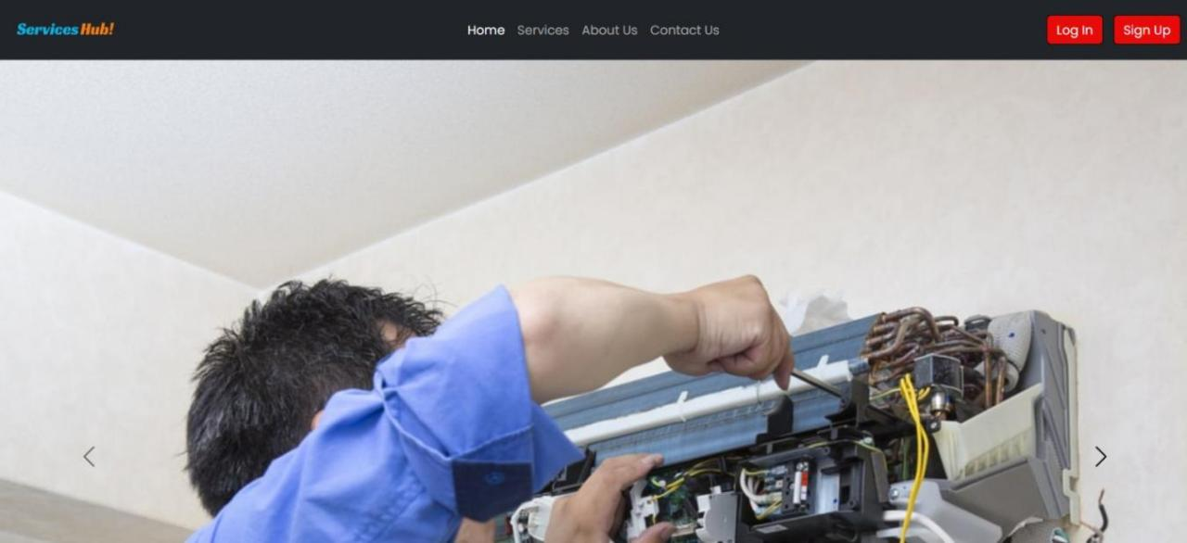
T

6.2. User

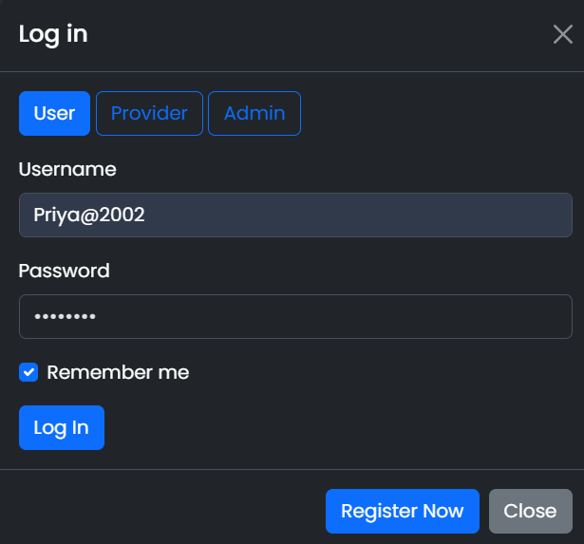
6.3. User Registration

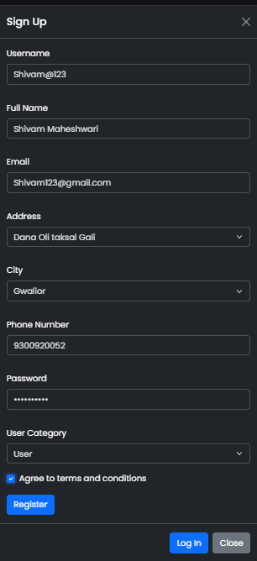

6.4. Provider Login

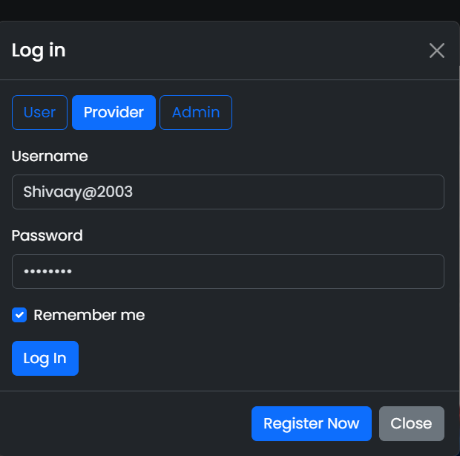
6.5. Provider Registration

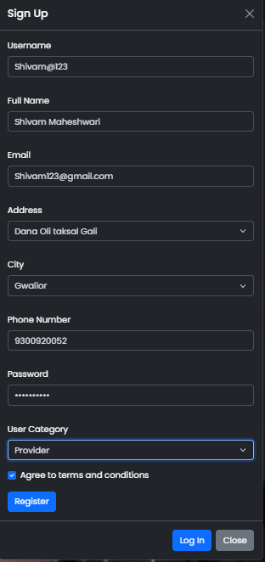

6.6. Admin

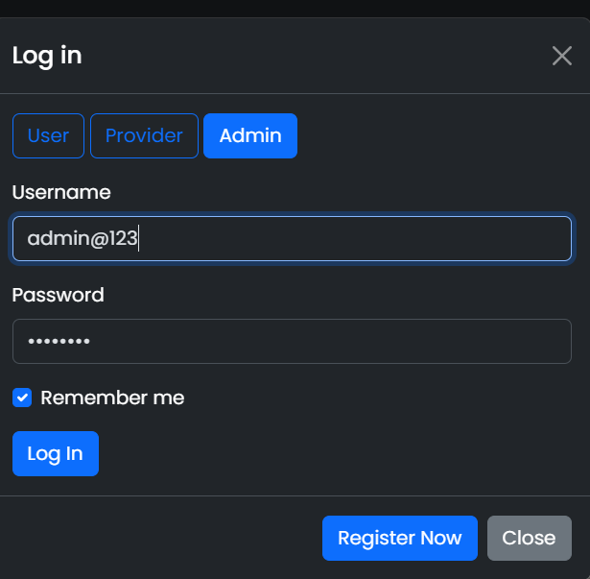
6.7. Services

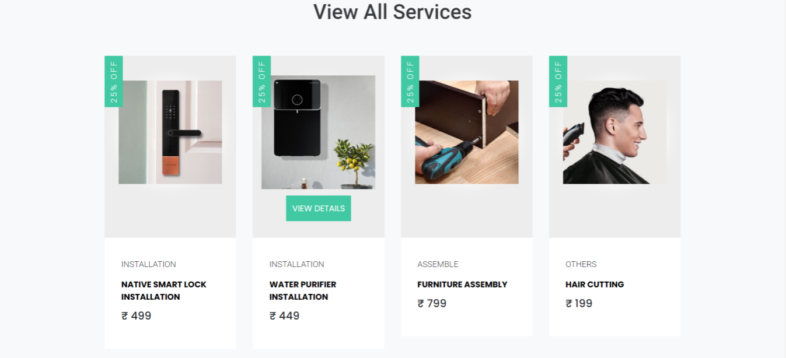

6.8. Services Detail Page

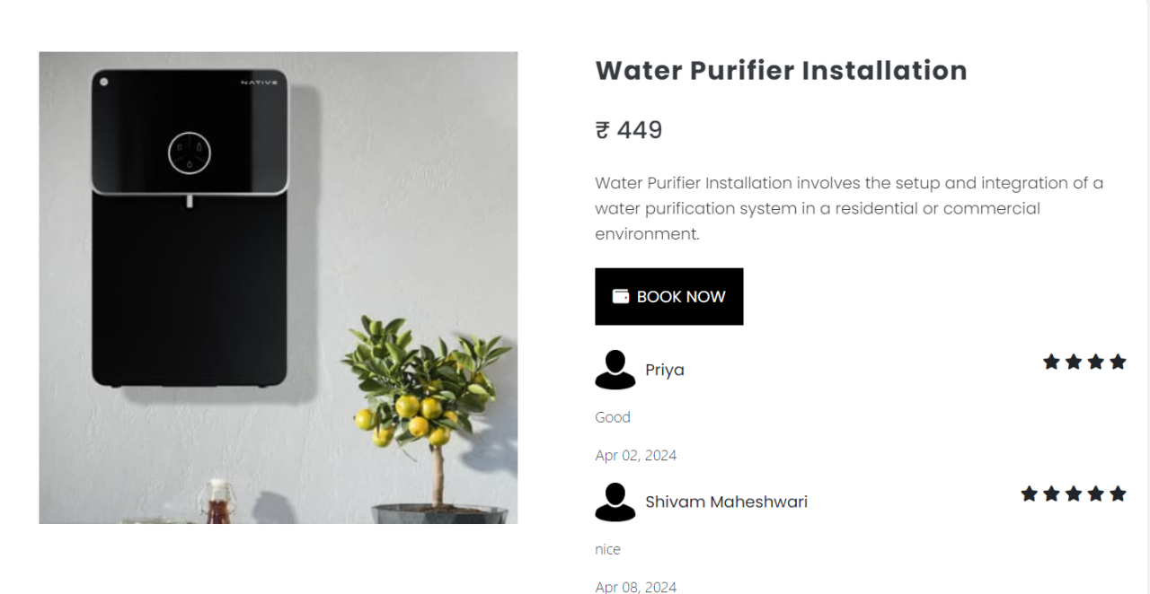

6.9. Book Services

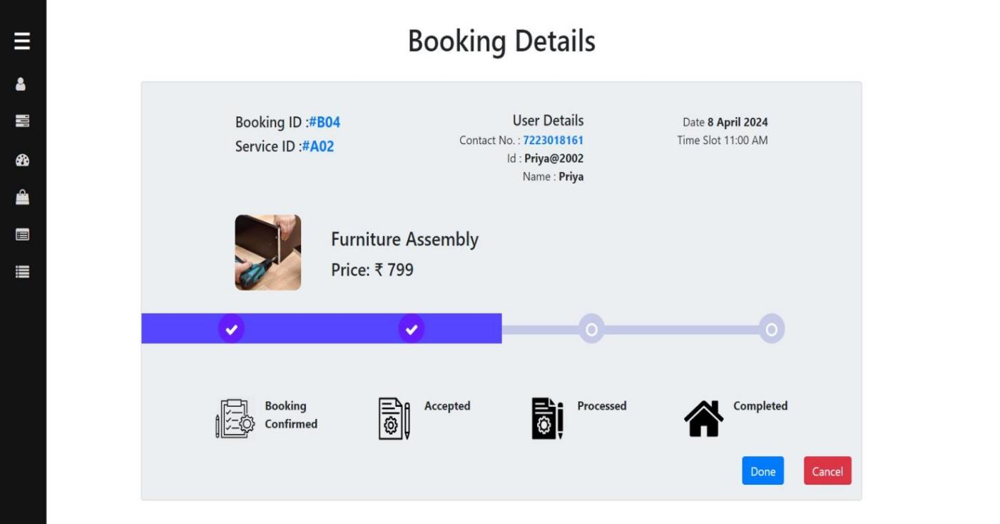

6.10. Booking Cancelled

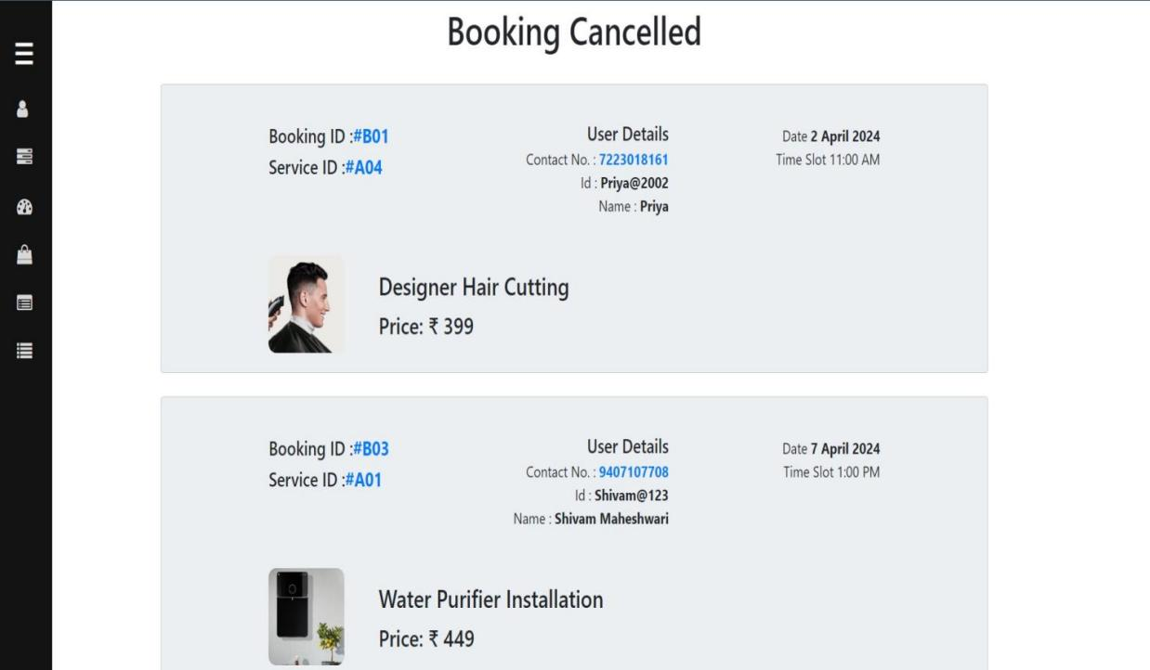

6.11. About us

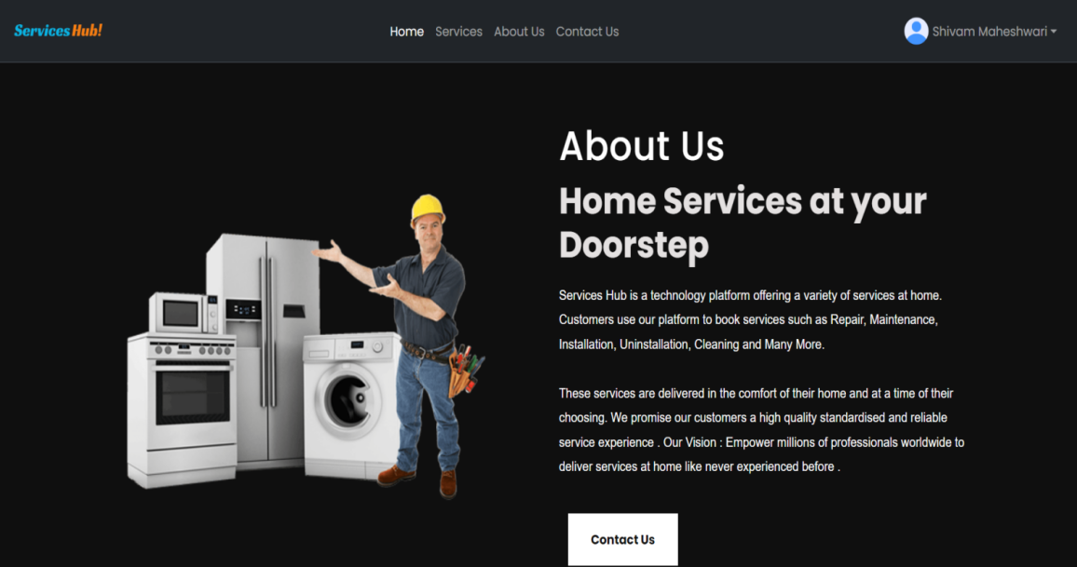

6.12. Contact Us

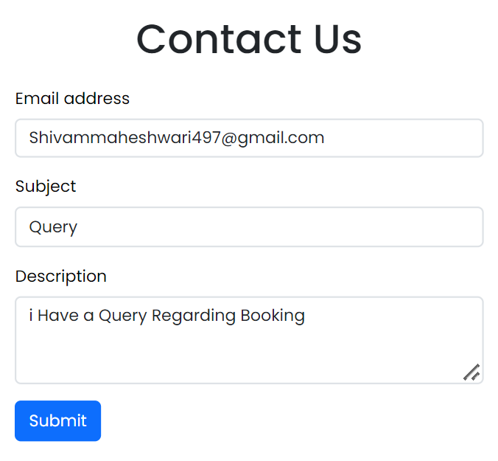

7. CONCLUSION AND FUTURE SCOPE
In conclusion, the Services Hub initiative proves to be a crucial response to the numerous difficulties local suppliers and consumers encounter while navigating the digital environment. This project supports local merchants and improves customer convenience and accessibility of services, all while promoting a feeling of community togetherness by creating smooth interactions between service providers and searchers.
With its user-friendly online application interface and focus on accessibility, Services Hub provides a simplified platform that allows customers to take use of a variety of home services, from cleaning and personal grooming to installations. The project successfully responds to the changing needs of contemporary consumers by utilizing technology to close the gap between offline service delivery and online interactions.

The project's economic viability is underscored by a comprehensive analysis of costs and resources, demonstrating its practical feasibility. Leveraging state-of-the-art technologies and platforms ensures the technical feasibility of Services Hub, promising a seamless experience for both vendors and customers alike. Moreover, the project's user-centrist design emphasizes ease of use, accessibility, and ongoing support, enhancing its behavioral feasibility and ensuring widespread adoption.

Beyond its technical and economic merits, Services Hub fosters positive social change by promoting sustainable consumption practices, preserving local livelihoods, and nurturing entrepreneurship within communities. By championing the interests of local businesses and facilitating meaningful connections between vendors and customers, the project catalyzes economic growth, job creation, and community development.

In essence, Services Hub transcends its role as a mere digital platform; it embodies a catalyst for societal transformation, a facilitator of meaningful connections, and a driver of community well-being. By embracing the intersection of technology and traditional service provision, this initiative charts a path towards a more connected, inclusive, and economically vibrant local ecosystem. Through Services Hub, communities don't just transact; they forge relationships, preserve heritage, and lay the groundwork for a sustainable future.

7.1 FUTURE SCOPE
A number of features might be added if this project needs to be improved and expanded upon in the future. First off, if chat were integrated within the site itself, users could contact with vendors easily and wouldn't need to rely on other programs. The purchasing process would be streamlined and consumer engagement would increase with this direct messaging solution. Furthermore, concentrating on UI/UX innovations would be essential to enhancing the general website experience. The site would become more visually appealing and user-friendly with layout and design improvements, which would increase user happiness and retention. Additionally, adding filter options to the website's product listings will improve search performance by enabling customers to locate relevant goods fast depending on their preferences.

Bibliography
S.no. | Website
i. | https://www.w3schools.com/html/default.asp
ii. | https://www.w3schools.com/css/default.asp
iii. | https://www.w3schools.com/js/default.asp
iv. | https://nodejs.org/en/download
v. | https://getbootstrap.com/
vi. | https://dev.mysql.com/downloads/installer/
vii. | https://sweetalert.js.org/
viii. | https://www.google.com/
ix. | https://www.fontawesome.com/

Plagiarism Report

